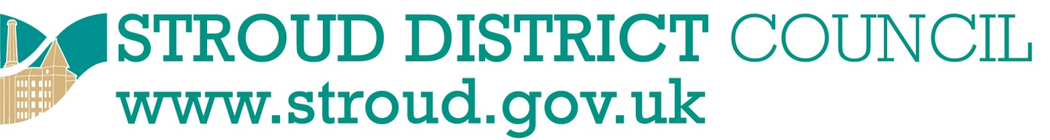

South West Procurement Portal

www.supplyingthesouthwest.org.uk

Stroud District Council has joined the Supplying the South West Procurement Portal. This allows potential suppliers to view all current contracts, receive notification of upcoming tenders and formally register their interest in opportunities to supply the participating councils.

Registration and use of the Portal is completely free of charge, and you will be able to update your own information as required.

You can register online at www.supplyingthesouthwest.org.uk

Registering on this portal means you no longer need to send unsolicited mail or produce expensive sales literature – we will alert you when a relevant opportunity is advertised.

When registering, it is important to use a dedicated email address for receiving notifications from the portal. Many organisations use individuals’ email addresses, which can cause difficulties when an employee is sick or on holiday.

We will publish the majority of our contract and tender opportunities on the Supplying the South West portal, alongside many other authorities in the South West region.

One registration will cover all participating authorities.

For assistance with registration and using the system please contact
Jo Spain, email jo.spain@stroud.gov.uk

