Community Mental Health Transformation Small Grants Programme 2023-2024

Frequently Asked Questions (FAQs)
Q. = Question | A. = Answer

Q. What do you mean by the term 'project'?
A. We use the term 'project' to refer to an endeavour you intend to deliver, with a definite start and end date, so that could be a specific piece of work you intend to deliver and/or ongoing services/work you provide.

Q. Can you apply for core costs for example, rent, supervision costs, training costs etc.?
A. Yes. If you have a look at the fund criteria and eligibility document (link) that is available on Gloucestershire VCS Alliance Mental Health webpage, then it has examples of the types of costs in Section 3.1 that you may apply for although the list is not exhaustive. For further information please contact the grants team smallgrants.enquiries@ghc.nhs.uk.
In your application you have the opportunity to tell us - 'About Your Project' This is where we want you to describe the work you want to do, how you plan to do it, and why you want to do it. Explain here if you are seeking funding for staffing costs, project costs and /or core costs.
Q. What is the closing date for applications?
A. 31st October 2023 – 12pm. Applications after this date cannot be accepted.

Q. What date must the project end?
A. End March 2025

Q. Do organisations who apply have to have an annual income within a certain range?
A. In short no. There is no upper (or lower) limit, but we may ask for further financial information to support your application if necessary.

Q. Do you accept applications from statutory services e.g., schools, prisons, hospitals)?
A. No. We do not accept applications from statutory services. We accept applications from Voluntary, Community and Social Enterprise (VCSE) organisations, i.e., community groups and clubs; charities, social enterprises and other not-for-profits. We can consider joint applications that are a partnership between a VCSE organisation and a statutory organisation. In this instance the VCSE organisation would need to be the lead partner.

Q. Can Community Interest Companies apply?
A. Yes

Q. Do you accept applications from individuals / sole traders?
A. We are not able to accept application if you are an individual/sole trader or a for profit business such as a partnership or company.

Q. When will successful applicants receive their grant?
A. Funding will be awarded from December 2023-March 2024

Q. When will the grants have to be spent by?
A. The grant must be spent by end March 2025.

Q. Do we need to send policies with our application?
A. No. Please don’t send any additional documents with your application unless we specifically ask you to. Applicants receiving a conditional offer of funding will be asked to provide supporting financial and governance documents as set out in Section D of the application form.

Q. What is the maximum amount we can apply for?
A. Applications are sought from projects where funding is needed for 12 months up to a maximum of £10,000.

Q. Do applications have to be for new projects?
A. No. We are very happy to consider applications for funding that allows existing work to continue - however, one of the main aims is for your project/work to be transformational and innovative - please look carefully at the criteria in the criteria and eligibility document. We do not want people to create something new simply for the sake of applying; or to start adding in new elements that will make existing work unsustainable.
Please consider the sustainability of your project, make sure you have considered how you are going to maintain the project after the end of this funding. Any questions please just ask.

Q. What costs can be included as part of your budget?
A. Here are some examples of what your costs might include. It is not an exclusive list and core costs can be included specifically for the duration of project. If you have questions, contact smallgrants.enquiries@ghc.nhs.uk
- Staffing costs
- Training for volunteers
- Admin / research / evaluation time
- Session delivery / facilitation
- Insurance
- Set-up costs
- Equipment and/or storage
- Materials
- Refreshments
- Postage and stationery
- Venue hire
- Printing/leaflets/publicity
- Transport for participants
- Subscriptions / fees / memberships (eg. a Zoom account)

Q. Do we have to be working with people with a diagnosis?
A. No. Your project has to be working with adults experiencing severe mental illness, but they do not have to have a formal diagnosis.

Q. What do you mean by Severe Mental Illness (SMI)?
A. The NHS Community Mental Health Transformation Video outlines the essential information and learnings on the development of new integrated models of primary and community mental health for people with severe mental illness (SMI). It describes the principles of the Community Mental Health Framework for Adults and Older Adults as per the vision of the Long Term Plan.
The slide shown below is taken from this video and provides a visual on SMI examples:
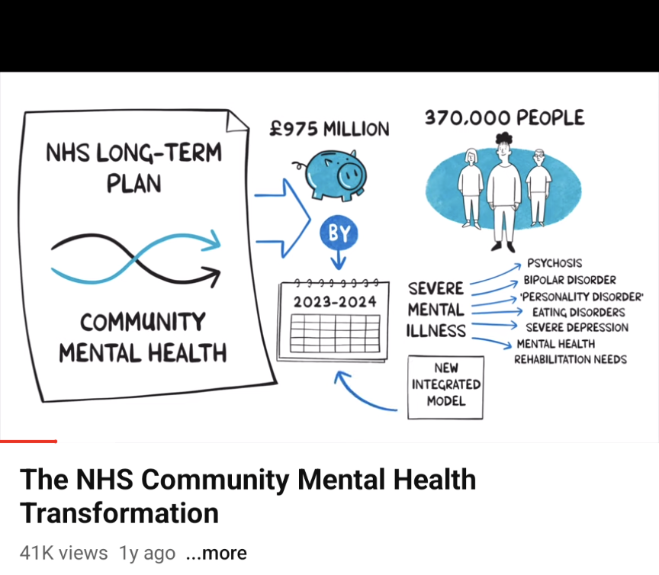
All this information is on the GHC CMHT website.

Q. Is my project eligible to apply?
A. Please take a look at the Grant Criteria and the application form
By looking at these documents this should help you decide if your project/work fits with this grant opportunity and your eligibility to apply.
There are some specific criteria your project must meet, please take a look at the Grant Criteria and if you have questions or need clarification then please get in touch.
All information can be found on GHC CMHT webpage or Gloucestershire VCS Alliance webpage

Q. We are wanting to apply as a collaborative project, is this possible?
A. We support and encourage collaborative proposals and great to see this type of partnership working. When applying if you can provide a supporting document to add further detail to explain the partnership working. If you require any clarification on what is required, please contact us.

Still got questions?
- Email: smallgrants.enquiries@ghc.nhs.uk.
- Visit GHC CMHT webpage for lots of information.

